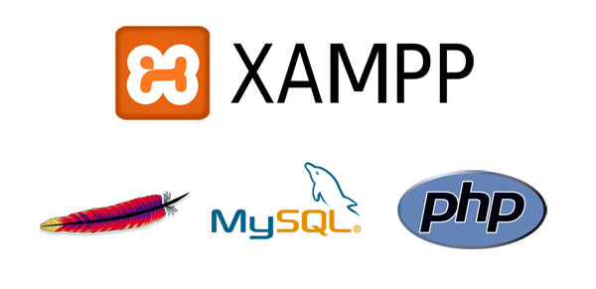

|  |
| --- |
| XAMPP tutorial  Author: Rob Sims |

|  |  |  |
| --- | --- | --- |
| XAMPP |  |  |
| Cross Platform  MySQL | Apache  PHP / Perl |  |

TABLE OF CONTENTS

Change log 3

Introduction 4

Notes 4

Part 1 5

XAMPP download and installation 5

Part 2 10

Running XAMPP, Starting Apache and MySQL 10

Opening XAMPP Control Panel and Starting Apache/MySQL 10

Part 3 13

Using XAMPP 13

Creating a MySQL database 13

Uploading your application files 15

Part 4 17

Further configuration 17

AutoStarting modules 17

Allowing upper case table names 18

Conclusion 21

# Change log

|  |  |  |  |
| --- | --- | --- | --- |
| Version | Date | Change | Author |
| 0.1 | 18/3/2018 | Initial Draft | Rob Sims |
| 1.0 | 19/3/2018 | Guide completed | Rob Sims |
| 1.1 | 19/03/2018 | Added config changes for upper case table names | Rob Sims |
|  |  |  |  |

# Introduction

In order to get started with your web or database development, you will need some basic software. In this guide we will download and install an easy to use software package called XAMPP. This simplifies the process of running an Apache webserver and MySQL database locally so you do not need any web hosting to develop and test your applications. It will prove invaluable when developing your own web based information systems.10

## Notes

For this tutorial we are assuming you are running Windows 10 and have not installed any of this software previously. You are encouraged to follow along with the screenshots to limit errors.

# Part 1

## XAMPP download and installation

Navigate to <http://sourceforge.net/projects/xampp/> to pick up the latest copy of the XAMPP software installer.

Save the installer to your desktop. When the download is complete, run the installer.

**Leave all the defaults as they are, except for the following:**

* **Uncheck the box to learn more about BitNami**
* **Uncheck the box to Start Control Panel Now**

Follow along with the screenshots to avoid confusion:

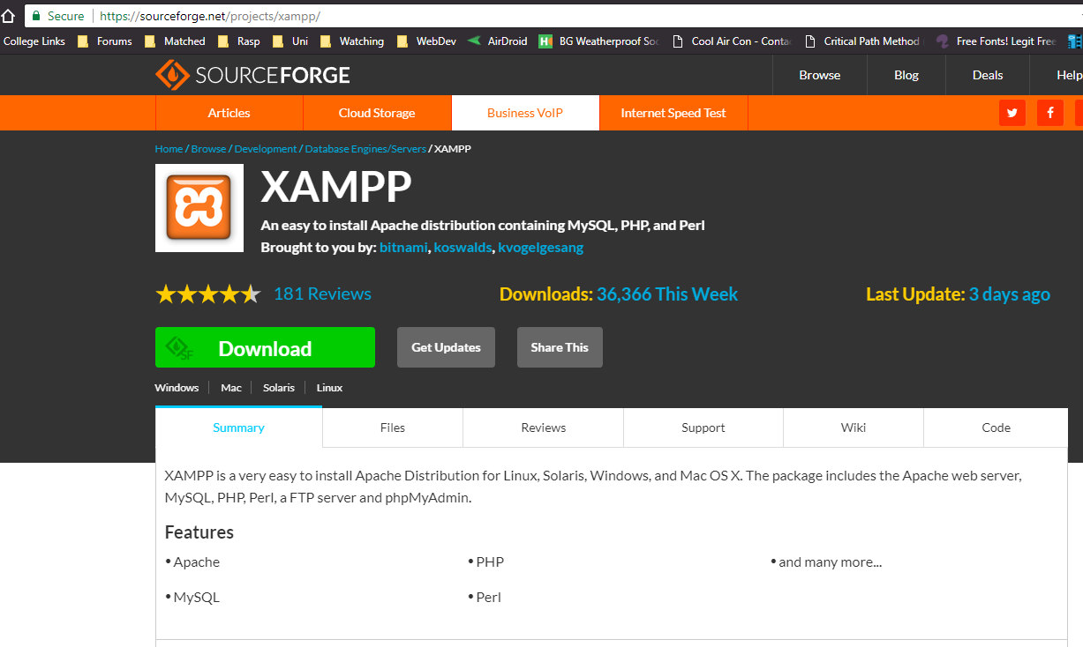

Figure Download XAMPP

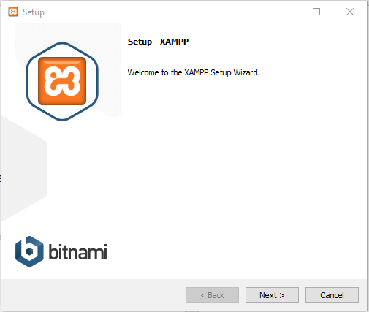

Figure Click next

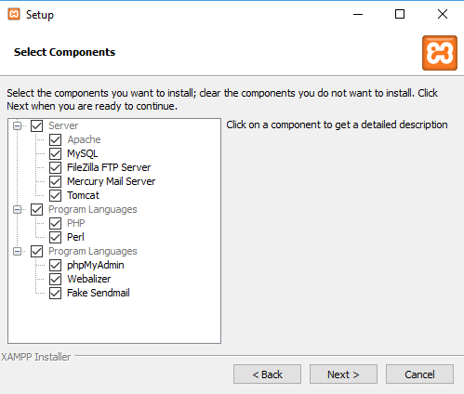

Figure Click next

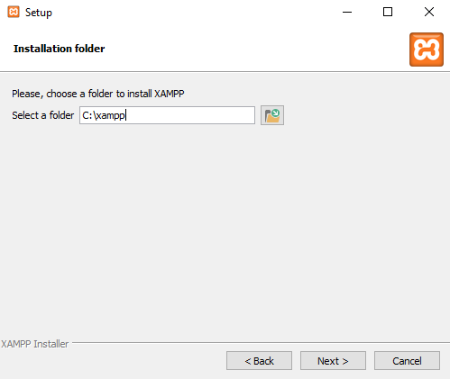

Figure Click next

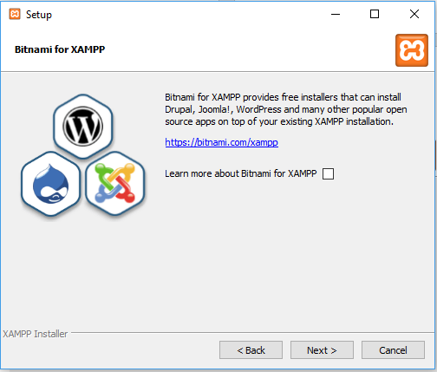

Figure De-select and click next

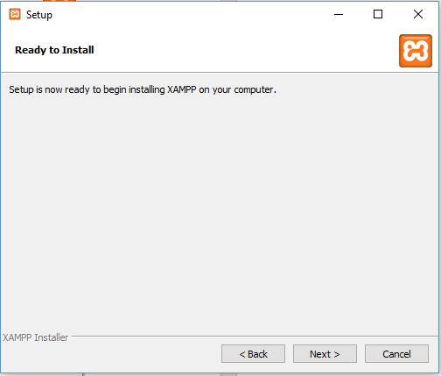

Figure Click next

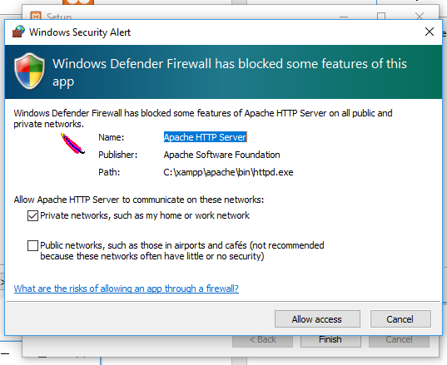

Figure You might need to allow access through your firewall

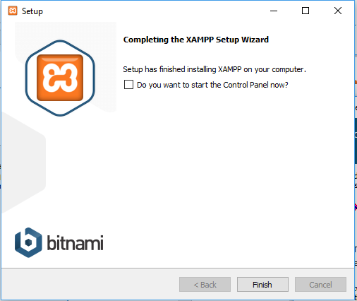

Figure De-select and click finish

# Part 2

## Running XAMPP, Starting Apache and MySQL

At this point you should have XAMPP installed. We will now show how to start the XAMPP Control Panel, start the Apache webserver, start the MySQL database, and run through first run configuration. We will then go through how to shutdown Apache and MySQL and close XAMPP.

### Opening XAMPP Control Panel and Starting Apache/MySQL

Open the XAMPP Control Panel by opening the Windows Start Menu and finding XAMPP Control Panel in the All Programs List. The Control Panel can take a few moments to initiate.

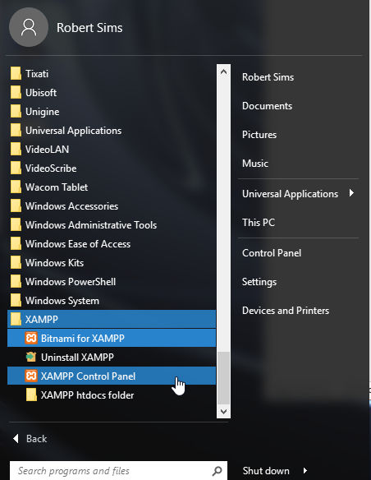

Figure Open XAMPP Control Panel

After you have opened the XAMPP Control Panel, you should see the following. Notice that the panel is also available from the system tray.

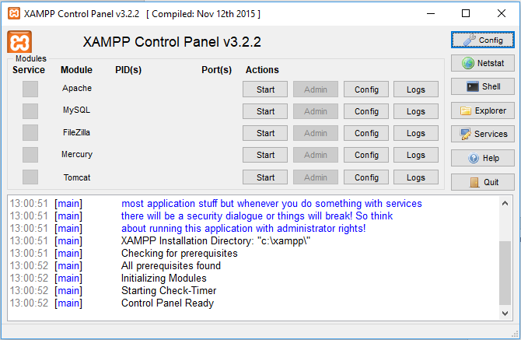

Figure XAMPP control panel

Start the Apache web server and MySQL database by clicking on Start under Actions. The Apache and MySQL modules should turn green in the Control Panel and indicate that they are running. (NOTE: If you use Skype, it is common for MySQL to start but not Apache. The reason is that Skype will occasionally use the same ports as Apache. To fix this, close Skype completely and try to run Apache again.) You might have to allow access through your firewall as well.

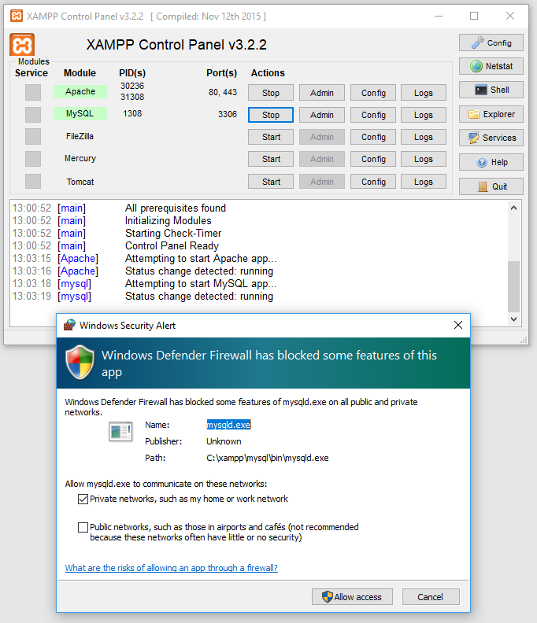

Figure Start Apache and MySql server and allow access through firewall

# Part 3

## Using XAMPP

So we’ve installed XAMPP and started the modules, but how do we actually use it for development?

### Creating a MySQL database

In the XAMPP Control Panel, once the Apache Server and MySQL Database have been started, click on the Admin button under Actions for Apache. Your web browser should open to a XAMPP splash page.

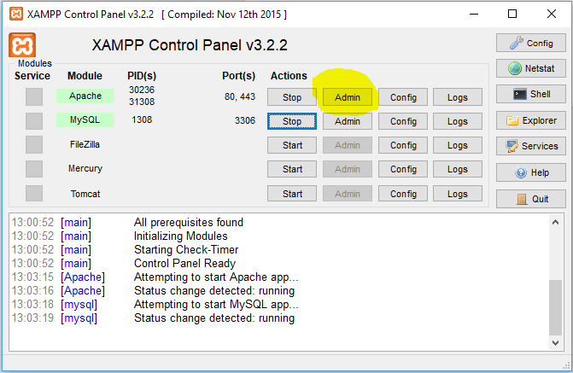

Figure Click Admin

Now click the phpMyAdmin on the web page that opens:-

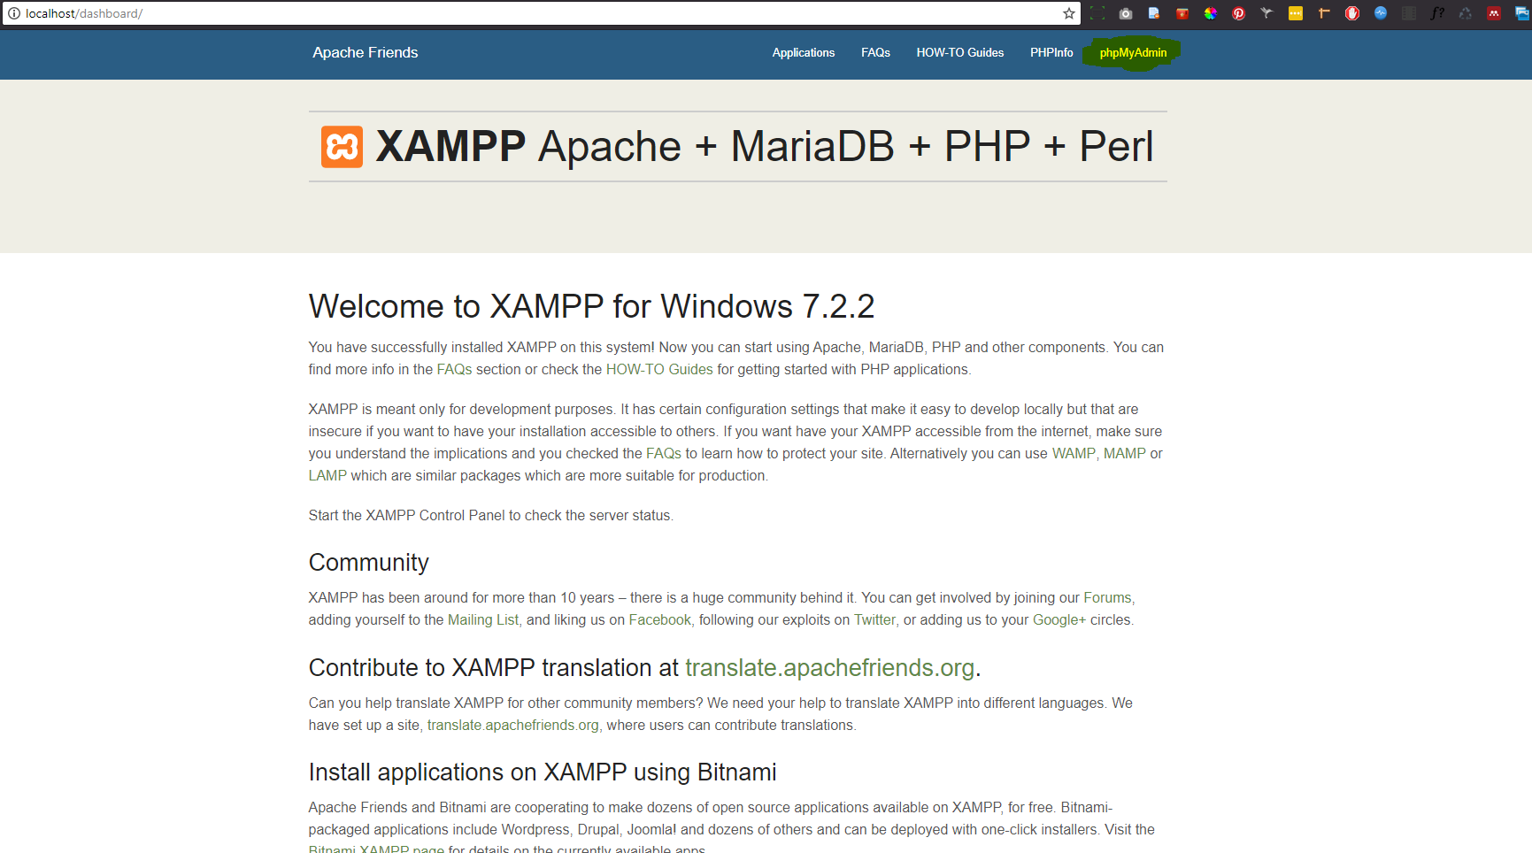

Figure Click phpMyAdmin

Now click the new option as follows:-

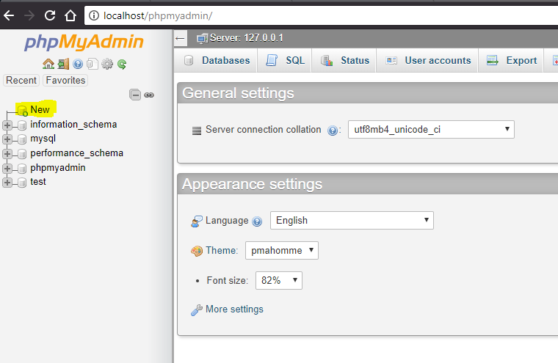

Figure Creating a new database

Create your database as per your database design documentation. Step by step instructions in creating a new database and populating it within phpMyAdmin are beyond the scope of this tutorial.

NOTE:- By default, the username to access the database is ‘root’ and the password is empty. The host is localhost and the database name is whatever name you gave to your database. So, if you were setting up a connection string within PHP, it would be as follows:-

$hostname="localhost";

$username="root";

$password=" ";

$database="database-name";

### Uploading your application files

Navigate to c:/xampp/htdocs – within there create a folder to ‘host’ your website. In this example I’ve created a folder called beyonce:-

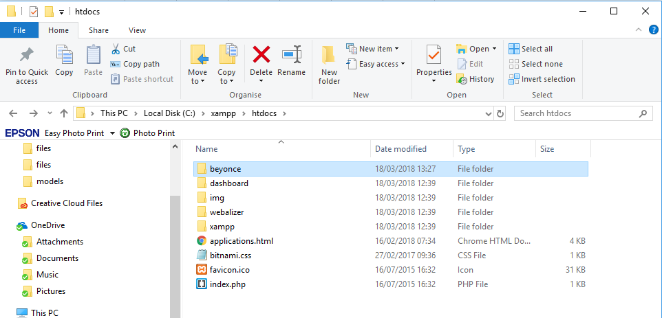

Figure htdocs location

Now all you have to do is simply copy all your web files into this new folder. Below you can see I’ve put all my beyonce website files in that directory:-

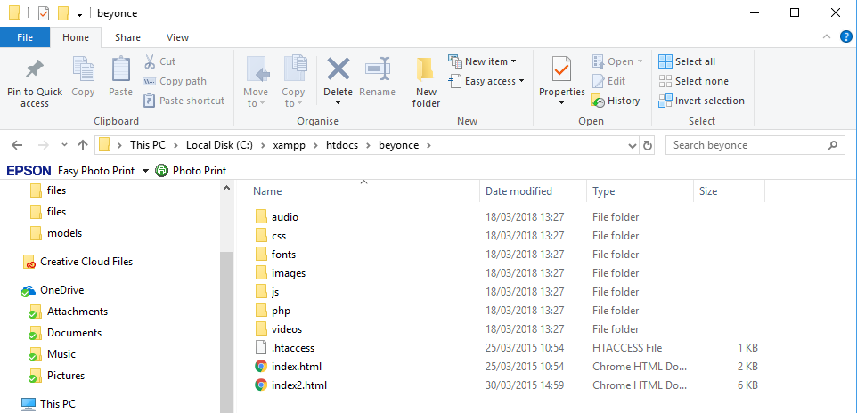

Figure Files copied to site folder in htdocs

To view your site, in a browser navigate to [http://localhost/<your web folder>/](http://localhost/%3cyour%20web%20folder%20%3e/). In my case, that’s <http://localhost/beyonce/> - you should now see your website:-

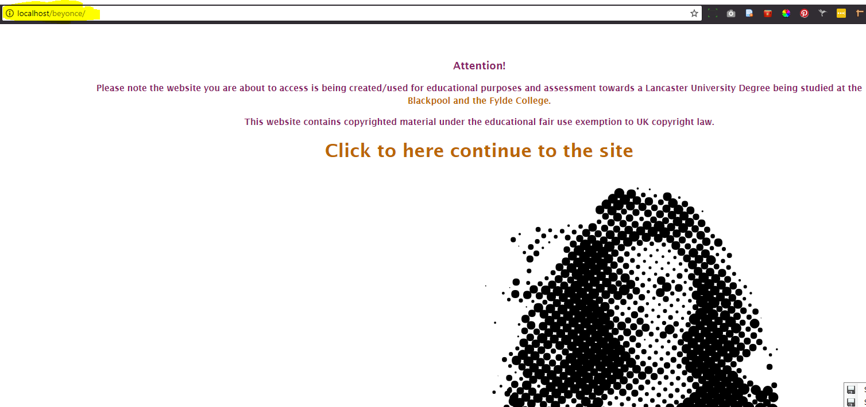

Figure Viewing your site

# Part 4

## Further configuration

There are further configuration changes that can make our development easier and more efficient.

### AutoStarting modules

By default, XAMPP doesn’t start Apache or MySQL when Windows starts. If you have a powerful machine (8 cores and 16gb ram recommended – i.e. Ryzen 1700 or Intel 6900k and higher), you can set these to auto start with Windows and leave them running, otherwise we’ll have to start these modules each time we want to use them (recommended for lower spec machines).

You set the modules to AutoStart by selecting config in the XAMPP control panel and selecting the modules to start with Windows:-

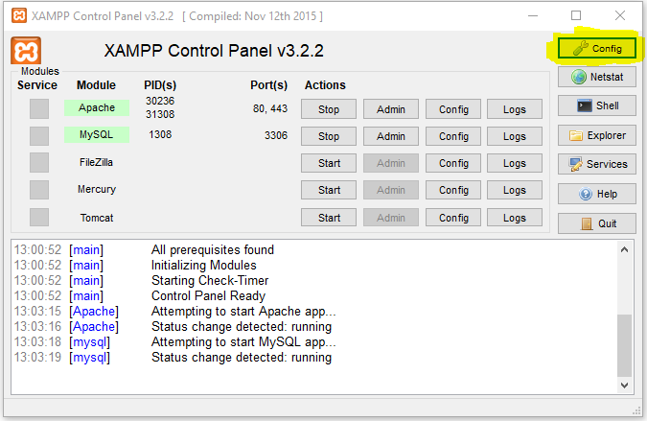

Figure Select Config

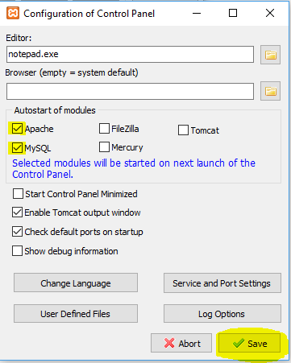

Figure Select Apache, MySQL then Save

### Allowing upper case table names

By default, MySQL within XAMPP doesn’t allow upper case table names. If you import an existing database with upper case table names they will be converted to lower case. THIS WILL CAUSE YOU PROBLEMS! But don’t worry, we can fix that. In the XAMPP control panel, click the config button for MySQL:-

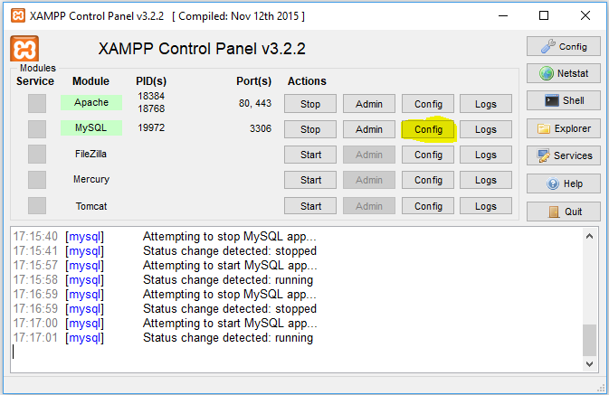

Figure Click Config

Now find the line [mysqld] and insert lower_case_table_names = 2 immediately after it.

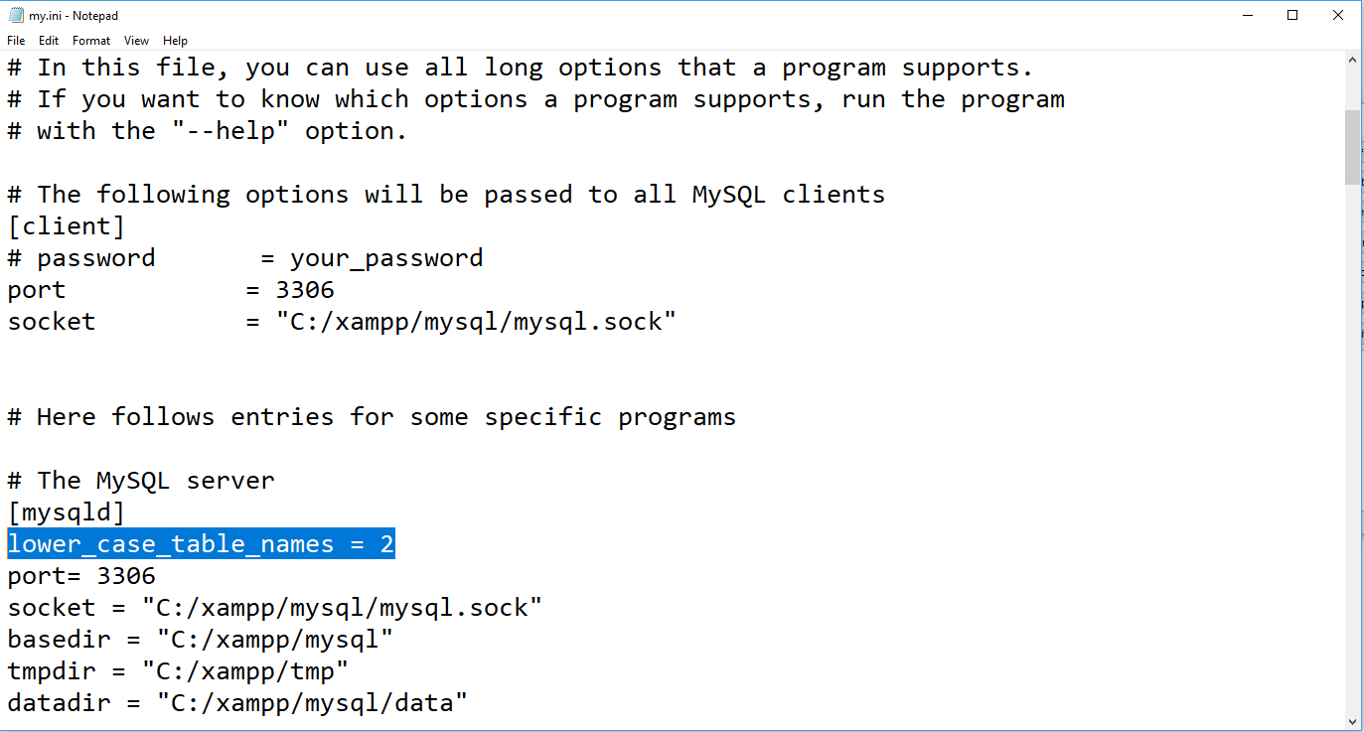

Figure Add the line show in the highlighted location

Restart the MySQL server by clicking stop then start:-

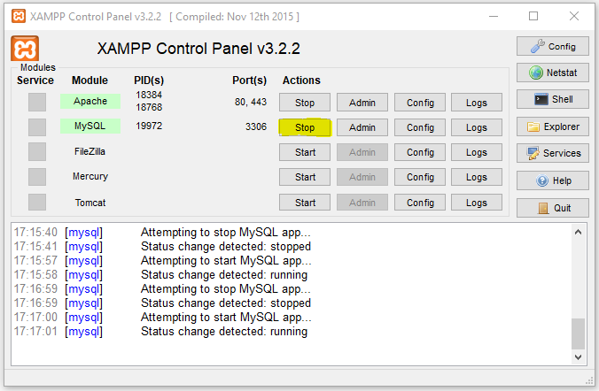

Figure Restart the server by clicking stop then start

Voila, you should now be able to create tables with upper case names.

# Conclusion

There we have it. We have set up an XAMPP install that runs the Apache web server and the MySQL database server so we can now develop locally and run database applications locally without the need to upload to a web host.

Happy Developing!